Global Mapper Documentation: Instructions
A shape can be defined in a text (.txt) file and then loaded into Global Mapper by using the ‘File->Open Generic ASCII Text File(s)’. Instructions for create this file are as follows.

Minimum requirements for a shape definition in an ASCII text file is the definition of three vertices with the initial vertex repeated at the end of the list. Supported coordinated definitions are:
- Decimal Degrees
- Degrees/Minutes
- Degrees/Minutes/Seconds
If Latitude is given before Longitude, the radio button in the ‘Coordinate Column Order’ before ‘Y/Northing/Latitude Coordinate First’ must be selected.
Here is an example of acceptable input and the shape that it produces:
45/44/14.58 N, 119/49/41.28 W,187.01
45/44/55.80 N, 119/44/36.12 W,171.41
45/45/55.18 N, 119/46/23.84 W,187.58
45/45/38.81 N, 119/48/15.67 W,188.21
45/44/14.58 N, 119/49/41.28 W,187.01 <<-note the initial vertex repeated

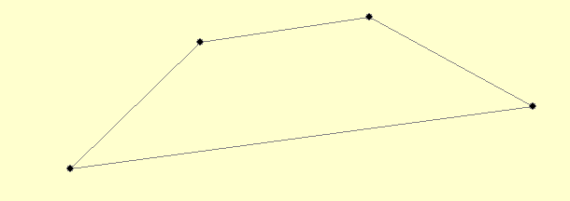

The color of the outline can be modified by appending any of the field titles in Section 7 of the document titled Global Mapper Documentation: Field Options to this file. Here is an example of acceptable input and the affect on the shape above:
LINE_COLOR=RGB(255, 0, 0)

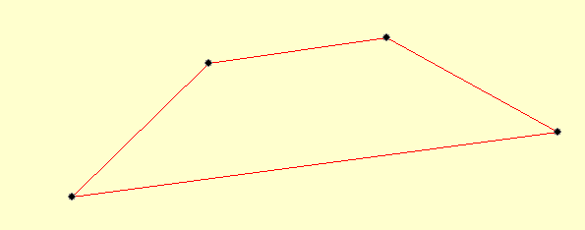

The width of the outline can be modified by appending any of the field titles in Section 8 of the document titled Global Mapper Documentation: Field Options to this file. Here is an example of acceptable input and the affect on the shape above:
LINE_WIDTH=6

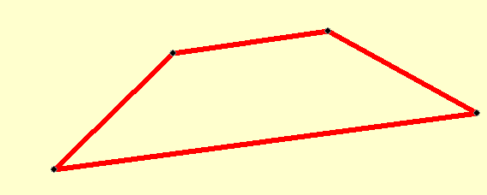

The style of the outline can be modified by appending any of the field titles in Section 9 of the document titled Global Mapper Documentation: Field Options to this file. Here is an example of acceptable input and the affect on the shape above:
LINE_STYLE=Dash – Dot

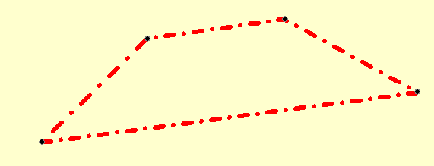

The shape can be filled with color by appending any of the field titles Section 11 of the document titled Global Mapper Documentation: Field Options to this file. Here is an example of acceptable input and the affect on the shape above:
FILL_COLOR=RGB(0, 0, 255)
CLOSED=TRUE <<-this line must be included to fill

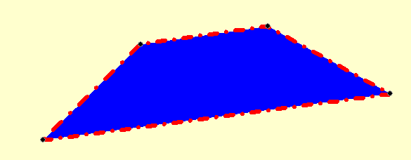

The shape can have a fill pattern added by appending any of the field titles in Section 10 of the document titled Global Mapper Documentation: Field Options to this file. Here is an example of acceptable input and the affect on the shape above:
FILL_STYLE=Backwards Diagonal Cross-Hatch
CLOSED=TRUE <<-this line must be included to fill

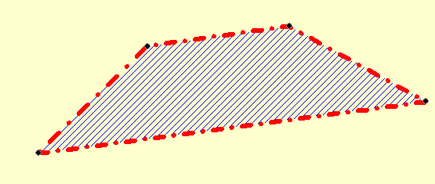

The shape can be named by appending any of the field titles in Section 1 of the document titled Global Mapper Documentation: Field Options to this file. Here is an example of acceptable input and the affect on the shape above:
NAME=Trapezoid 2

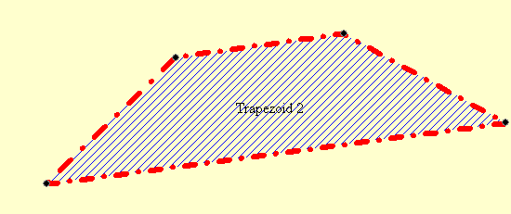

Additional fields may be found in the document titled Global Mapper Documentation: Field Options. Here are the entire contents of the file that created the shape above:
NAME=Trapezoid 2
LINE_COLOR=RGB(255, 0, 0)
LINE_WIDTH=6
LINE_STYLE=Dash - Dot
FILL_COLOR=RGB(0, 0, 255)
FILL_STYLE=Backwards Diagonal Cross-Hatch
CLOSED=YES
45/44/14.58 N, 119/49/41.28 W,187.01
45/44/55.80 N, 119/44/36.12 W,171.41
45/45/55.18 N, 119/46/23.84 W,187.58
45/45/38.81 N, 119/48/15.67 W,188.21
45/44/14.58 N, 119/49/41.28 W,187.01

